

Timeline to Prepare for Forum Meeting

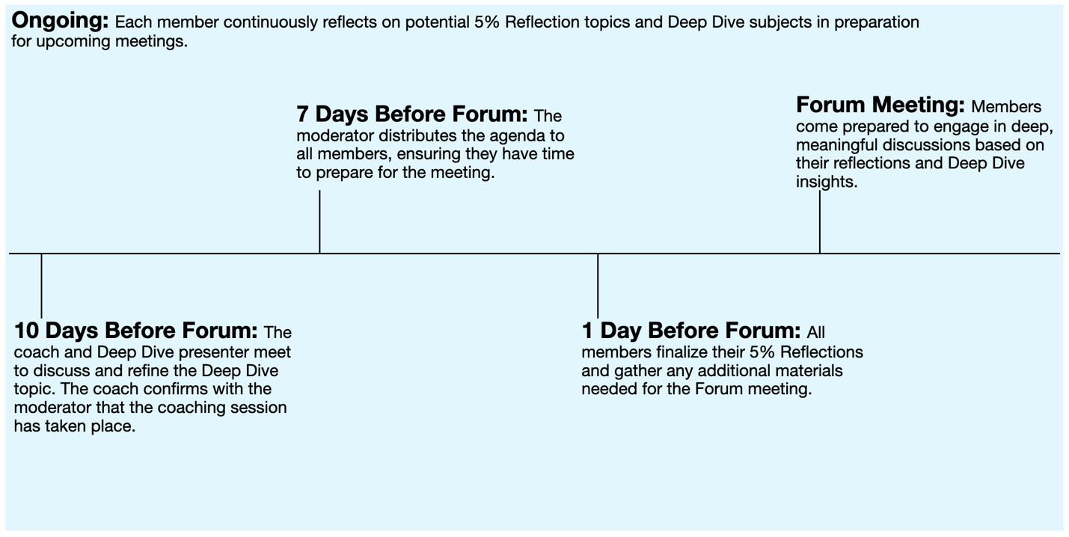

Sample Forum Roles & Responsibilities

Role | Responsibilities | Term | Selection Process
Moderator | Leads the Forum by preparing and distributing the agenda one week in advance, assigning roles, guiding discussions, and ensuring Forum administration runs smoothly. Leads by example. | One year | Election
Moderator-Elect | Supports the Moderator and facilitates meetings in their absence. Attends Moderator training and prepares to transition into the Moderator role. | One year | Election
Retreat Planner(s) | Plans and coordinates the Forum retreat. May delegate logistics to one person and content planning to another. | Variable | Volunteer
Member | Upholds the Forum’s constitution, confidentiality, and commitment standards. Actively participates, attends meetings, and presents at least once a year. | Ongoing (as long as compliant and contributing) | Group consensus
Parking Lot Attendant | Tracks and maintains a list of upcoming Deep Dive topics, records key themes from monthly 5% reflections, and keeps the Parking Lot discussion relevant. | One year | Volunteer
Timekeeper | Manages time during Forum meetings, provides warnings for time limits, and ensures discussions stay on track. | Variable | Volunteer
Social Manager | Organizes and oversees Forum social events, such as holiday gatherings, summer picnics, and other community-building activities. | Variable | Volunteer
Representative | Coordinated with RF, facilitates recruiting of new members, communicates relevant RF information with the Forum. | One year | Volunteer

